Team 1
ELEC 4000 Senior Design
Prepared for Dr. Thaddeus Roppel

Design Team Members:
Ed Budimier
Adam Gould
Jens Johnson
David Mason
Shaquana Peterson

Project Description
The goal of our senior design project is to create a helicopter which is capable of autonomous: lift-off, point A to B navigation, obstacle avoidance and landing. All objectives will be performed within a given environment without crashing.
Technical Approach
Our team has decided to acquire a manufactured model helicopter and modify it to be able to support other components (sensors, microcontroller, battery, etc.) that are needed to accomplish our goal. The helicopter will be retrofitted to interface with a separate control station. This will be accomplished by attaching a microcontroller to the helicopter so that it may operate autonomously based on the information that is collected through the onboard sensors. The control station will remotely transmit limited commands to the receiver mounted on the helicopter to initiate taking off, autonomous flight, and landing. The programmed microcontroller will also dictate the helicopter’s action while in flight when an obstacle is encountered.
After doing significant research on the various parts, looking at specifications and financial considerations, we have decided on the parts shown in the budget section included in this proposal. When considering what helicopter to use as our frame for the project three models are compared side by side in the Pugh chart below. The WarHawk 300 RC helicopter allows for full range of motion (being a 4 channel controlled model) which also allows us to modify its components to handle the greater load involved with carrying multiple sensors, a controller, and a bigger battery.

Helicopter | Exceed RC 2.4Ghz WarHawk 300 | Double Horse 9101 | EXI 450
Channels | 4 | 3 | 6
Base Battery | 7.4 volt | 7.4 volt | 11.1 volt
Balance | Co-Axial mechanism | Built-in gyro | Gyro/tail servo
Dimensions | 16”x16”x13” | 21”x28”x11” | 25”x28”x9”
Control | Radio | Radio | Radio
Price | $99.95 | $69.95 | $79.95

Team Management
In order to be successful in managing the semester long senior design project, a well defined process needs to be put into place. Fortunately the team was provided with a syllabus at the beginning of the semester which can be used as an outline for how the design process needs to be carried out. The syllabus only provides a limited amount of information needed to successfully complete the design process. Additional information comes from past experience, available resource material, and continuing research.
Due to the fact that this project is not being overseen by a for-profit organization, motivation can be a delicate thing to provide for the team. Part of the motivation may come from the peer evaluations and the prospect of receiving a good grade. However, ideally each team member would have a significant level of self motivation.
The main goal of managing a team is to make sure all work is completed on time, in its entirety, and to the best of the team’s ability while maintaining that the company vision is implemented efficiently and effectively. This, of course, is the ideal situation for a manager. Though, in most cases things are not so evenly balanced and it becomes difficult to ensure that this ideology is achieved. In order to maintain a good balance within the team proper expectations need to be set early through a team charter and project description. These items define where the team is going, and what short-term goals need to be met along the way.
Technically speaking all team members should have taken the same basic courses in order to be participating in the current project. This does not denote that all team members possess the same level of expertise in all aspects of our program. A good manager is flexible and able to adapt with their team members in order to take advantage of their experience and knowledge. However, it’s also the duty of each individual to express their strengths and weaknesses so that a manager can utilize each team member to the best of their ability. Those who are not comfortable in a given skill set would benefit from working alongside another group member that is proficient in the same area.
Communication is another key aspect to operating a successful design team. Open and respectful lines of communication should exist amongst the team members and with people outside of the team. Communication within the team should include brainstorming sessions and listening sessions. Brainstorming sessions should be open and inviting to new ideas. Each person should get a chance to express their ideas without them being shot down. These techniques will encourage future idea proposals. Communication outside of the team includes talking with the supervising professor, professors with relative experience, other teams, and professionals outside the academic community for advice in their field of expertise.
Feedback should also be given to each member as often as possible, whether it be positive or negative, to ensure the best approach is being taken to complete a task.
An appointed record keeper should record all ideas and track the minutes of the meetings. Tracking how our time is spent will allow us to manage and measure our time efficiency. A record will be kept online through the use of our team website.

Social Impact
Expensive hobbies can create a measurable economic impact, create jobs, and inspire new creations that work toward the bettering of man.
The use of an aerial vehicle with autonomous capabilities can have a tremendous impact on society, especially from a military aspect. Once UAV’s were put into use by the U.S. military they saved lives and resources. This gave the public a sense of security and an appreciation toward the military for the value they placed on the lives of their uniformed loved ones.
UAV’s are not only used for military purposes though; they can be used for recreation as well. If a product is widely successful it can create its own sub-culture of followers, which in turn can lead to the formation of competitions and leagues. Demand will rise as popularity increases and as a consequence the product supply must respond accordingly. As new factories open and sales increase more jobs will be created.
Advancements in technology open doors to further create and inspire continued technological advances. Our product and subsequent technology could be the jumping point of an even greater scientific achievement. All of which positively affect our society.
Political Impact
The political impacts of readily available autonomous helicopters could have great political impact. The average person will be able to send items from place to place or even explore areas remotely through the helicopter. They could be used to improve international relations by using them for disaster and emergency aid in other countries. On the other hand they could cause international politics to be more tenuous if the autonomous helicopters are used to spy on and gather intelligence on other countries without their permission.
Health and Safety
In regards to the health and safety of the future customers of our product there is minimal risk involved with the system. As the helicopter is autonomous there is no danger to the owner of the product. The sensors are ultra-sonic and pose no health risk. The user has only to turn the system on and let the product function as designed.
As is common with any manufacturing process there is a certain level of risk to those involved in the assembly of our product. However, current laws and restrictions attempt to limit unnecessary damage to the health of the employees of the manufacturers.
Our product’s applications can be to the benefit to our society’s health and safety. Some of the applications include, but are not limited to, flying through collapsed mines, caves, or buildings for rescue operations. Currently there are robots designed to enter buildings during dangerous situations in the place of people so as not to risk human life. As the weight of these robots can be substantial, circumstances that include unstable flooring create difficult and potentially unmanageable situations. An autonomous helicopter would be perfectly suited to enter a structure with zero impact to the stability of the building.
Manufacturability
An autonomous helicopter with the ability to move through any environment without running into obstacles can be manufactured for a just a slightly higher cost than most other model helicopters. Should the manufacturing be done in house, existing machines and assemblies can be purchased used to create the various components of the helicopter and the helicopter itself. New machines will have to be made or modified in order to assemble all the components into the final product. Else, contracts can be made with current manufacturing companies to modify their existing helicopters to include the additional components needed to meet our requirements. Through the use of competitive contracting, a company can establish a manufacturing process quickly and should be able to keep their costs to a minimum.
Sustainability
Sustainability means the capability to endure as well as being able attain development or redevelopment of a product. When producing any type of product, one should consider sustainability; whether it is a product for adults, children, animals, etc. For instance, an aircraft needs to be able to sustain a number of things in order to ensure the safety of the people aboard an aircraft. It should be able to endure undesirable weather, stability, high altitudes, etc.
In our case, since our project consists of producing an autonomous aircraft, it needs to be able to tolerate object avoidance as well as altitude control in order to withstand indoor flight. It also needs to be durable enough to hold all of the components that are needed to construct the aircraft. Sustainability is also a factor in whether a product is successful or not; if it is unable to sustain certain aspects or qualifications then the product can be deemed unsuccessful.
Budget
Budgeting is very important in every financial plan. A good budget can help keep your spending under control and even leave room to put the extra money toward any other financial needs that may occur. So, with keeping the need for a good budget in mind, we first discussed our approach for the design of our project so that we could produce an effective budget. We then researched some of the same general parts and compared pricing on each item with the aim to come up with the cheapest, yet effective products. We decided to buy a commercially available helicopter rather than constructing our own, because we established that it will help to maintain a sufficient budget as well as create space for the amount of time needed for trial and error. We then constructed the table as shown below, which displays the cost of each product as well as the total estimated cost for the project.
Component | Supplier | Unit Cost | Quantity | Total Cost
Exceed RC 2.4Ghz WarHawk 300 4-Channel Radio Remote Control RC Helicopter RTF Co-Axial | xheli.com | $99.95 | 1 | $99.95*
Arduino Pro Mini 328 Control Board | sparkfun.com | $18.95 | 1 | $18.95*
FTDI Basic Programmer | sparkfun.com | $13.95 | 1 | $13.95*
Maxbotix Ultrasonic Rangefinder | microcenter.com | $24.99 | 1 | $24.99*
Infrared Proximity Sensor Long Range | sparkfun.com | $14.95 | 1 | $14.95*
Tilt Compensated Compass | sparkfun.com | $6.95 | 1 | $6.95*
Proto Board | sparkfun.com | $2.95 | 1 | $2.95*
Polymer Lithium Ion Battery | sparkfun.com | $6.95 | 1 | $6.95*
Total Estimated Project Cost |  |  |  | $189.64

*Note: Shipping and handling not included.

Components | Description
Exceed RC 2.4Ghz WarHawk 300 4-Channel Radio Remote Control RC Helicopter RTF Co-Axial  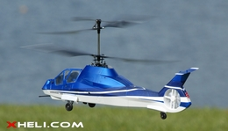 | This is one the most powerful co-axial RC helicopter created by Exceed RC. It has the most powerful motors in its class. The WarHawk300 Metal 2.4G Edition is equipped with 2.4G radio system and metal upgrades as well. Co-Axial Mechanism - Stable Flight! Easy to Control!
Arduino Pro Mini 328 Control Board  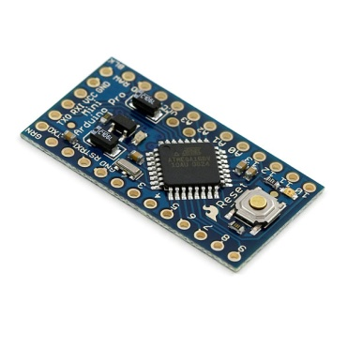 | Used to input data from sensors and IO from computer to run helicopter and controller
FTDI Basic Programmer  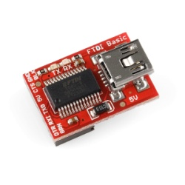 | Used to import data from the Arduino Pro Mini 328 Control Board and the computer
Maxbotix Ultrasonic Rangefinder  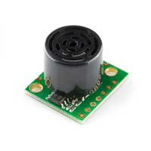 | Ultrasonic sensor used for object avoidance
Infrared Proximity Sensor Long Range  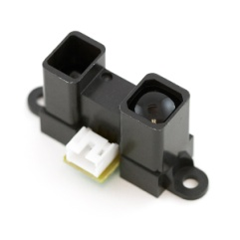 | Proximity sensor used for altitude control
Tilt Compensated Compass  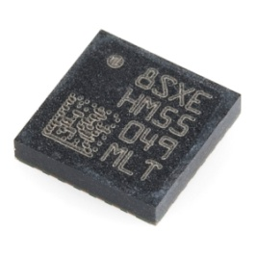 | Used for tracking direction
Proto Board  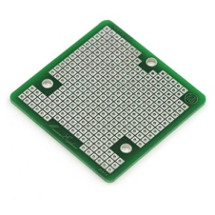 | Used to mount other components together
Polymer Lithium Ion Battery  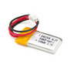 | Used to power the motor of the helicopter

Facilities to be Used
For our project we will need to use specific facilities that meet our needs and then also general locations that suit our requirements. The specific facilities that we will need are Lab 307 in Broun Hall of Auburn University to program our controllers, solder the various connections, and build our auto-copter. Although some of the construction may be done at the residences of the individual group members, ideally the entire project would be put together on campus.
We will also need to find a place that we can test fly our project once we reach that stage of the process. A suitable site would be one that has a relatively large open space with a high ceiling. This might also be accomplished by testing outside, but we would like to eliminate any elemental factors that may interfere with our flight controls. Performing our tests indoors allows us to test and modify in short order and produces a rapid turnaround for trouble-shooting. Other facilities that we will be using as our general meeting location is Room 238 of Broun hall. This room has already been reserved for our class on Mondays, Wednesdays, and Fridays from two to three pm.

Project TimeLine

Week 1: Brainstorming, consensus on project selection and basic design.
Week 2: Delegation of tasks to be completed by each member of the group.
Week 3: Completion of proposal and finalization of purchase choice and project goals
Week 4: Finalization of required for project.
Week 5: Purchase of parts
Week 6: Construction of the helicopter. Flight tests to measure stability and handling of the helicopter
Week 7: Modification of helicopter circuitry to accept commands from the microcontroller.
Week 8: Construction of code to allow for basic autonomous operation of the helicopter.
Week 9: Continuation of coding.
Week 10: Troubleshooting.
Week 11: Demonstration!!!

Disposition
Any group member wishing to obtain sole ownership of any items previously co-held by the group will provide adequate compensation for such items as is. Any remaining unwanted property will be donated to an establishment of our choice.

_______________________________ _______________________________
Ed Budimier Adam Gould

_______________________________ _______________________________
Jens Johnson David Mason

_______________________________
Shaquana Peterson

